DEPARTMENT OF INFORMATION TECHNOLOGY

SMT. PARMESHWARIDEVI DURGADUTT TIBREWALA
LIONS JUHU COLLEGE
OF ARTS, COMMERCE AND SCIENCE
Affiliated to University of Mumbai (Autonomous)
J.B. NAGAR, ANDHERI (E), MUMBAI-400059
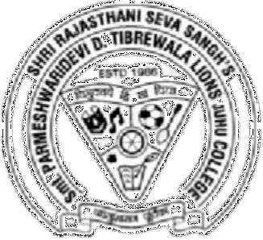
Academic Year 2025-2026
COMPUTER VISION
For

Semester II

Submitted By:

Mr. Mohd Sahbaz Chaudhary
Msc.IT (Sem II)

SMT. PARMESHWARIDEVI DURGADUTT TIBREWALA LIONS JUHU COLLEGE
OF ARTS, COMMERCE AND SCIENCE
Affiliated to University of Mumbai (Autonomous)
J.B. NAGAR, ANDHERI (E), MUMBAI-400059

DEPARTMENT OF INFORMATION TECHNOLOGY
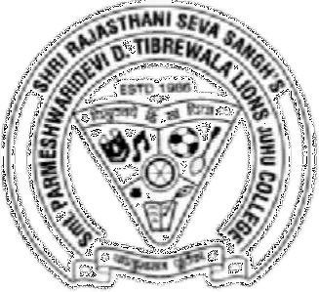
Certificate of Approval

This is to certify that practical entitled “COMPUTER VISION”, Undertaken at SMT.PARMESHWARIDEVI DURGADUTT TIBREWALA LIONS JUHU COLLEGE OF ARTS, COMMERCE & SCIENCE.
By Mr. Mohd Sahbaz Chaudhary Seat No. MIT251001 in partial fulfilment of M.Sc. (IT) master degree (Semester II) Examination had not been submitted for any other examination and does not form of any other course undergone by the candidate. It is further certified that he has completed all required phases of the practical.

Internal Examiner External Examiner

HOD / In-Charge / Coordinator Signature/
Principal/Stamp

INDEX

Practical No | Details | Page No. | Date | Sign
1 | Perform Geometric transformation | 4 | 07-03-2026
2 | Perform Image Stitching | 6 | 07-03-2026
3 | Perform Camera Calibration | 8 | 07-03-2026
4 | Face Detection | 12 | 14-03-2026
5 | Object Detection | 14 | 14-03-2026
6 | Pedestrain Detection | 18 | 20-03-2026
7 | Perform Feature extraction using RANSAC | 21 | 20-03-2026
8 | Perform Colorization | 23 | 20-03-2026
9 | Perform Image Matting and Composting | 25 | 20-03-2026

